

# Rossmoyne Senior High School

### Semester One Examination, 2016

### Question/Answer Booklet

# MATHEMATICS

**SPECIALIST**

**UNIT 3**

## Section Two:

## Calculator-assumed

Your Name

Your Teacher

## Time allowed for this section

Reading time before commencing work: ten minutes

Working time for section: one hundred minutes

## Materials required/recommended for this section

***To be provided by the supervisor***

This Question/Answer Booklet

Formula Sheet (retained from Section One)

***To be provided by the candidate***

Standard items: pens (blue/black preferred), pencils (including coloured), sharpener, correction fluid/tape, eraser, ruler, highlighters

Special items: drawing instruments, templates, notes on two unfolded sheets of A4 paper, and up to three calculators approved for use in the WACE examinations

## Important note to candidates

No other items may be taken into the examination room. It is **your** responsibility to ensure that you do not have any unauthorised notes or other items of a non-personal nature in the examination room. If you have any unauthorised material with you, hand it to the supervisor **before** reading any further.

## Structure of this paper

|  |  |  |  |  |  |
| --- | --- | --- | --- | --- | --- |
| Section | Number of questions available | Number of questions to be answered | Working  time (minutes) | Marks available | Percentage of exam |
| Section One:  Calculator-free | 7 | 7 | 50 | 53 | 35 |
| Section Two:  Calculator-assumed | 12 | 12 | 100 | 98 | 65 |
|  | | | **Total** | 151 | 100 |

## Instructions to candidates

1. The rules for the conduct of examinations are detailed in the school handbook. Sitting this examination implies that you agree to abide by these rules.
2. Write your answers in this Question/Answer Booklet.
3. You must be careful to confine your response to the specific question asked and to follow any instructions that are specified to a particular question.
4. Spare pages are included at the end of this booklet. They can be used for planning your responses and/or as additional space if required to continue an answer.

* Planning: If you use the spare pages for planning, indicate this clearly at the top of the page.
* Continuing an answer: If you need to use the space to continue an answer, indicate in the original answer space where the answer is continued, i.e. give the page number. Fill in the number of the question that you are continuing to answer at the top of the page.

1. **Show all your working clearly**. Your working should be in sufficient detail to allow your answers to be checked readily and for marks to be awarded for reasoning. Incorrect answers given without supporting reasoning cannot be allocated any marks. For any question or part question worth more than two marks, valid working or justification is required to receive full marks. If you repeat any question, ensure that you cancel the answer you do not wish to have marked.
2. It is recommended that you **do not use pencil**, except in diagrams.
3. The Formula Sheet is **not** to be handed in with your Question/Answer Booklet.

Section Two: Calculator-assumed 65% (98 Marks)

This section has**twelve (****12)** questions. Answer **all** questions. Write your answers in the spaces provided.

Working time for this section is 100 minutes.

Question 8 (5 marks)

Consider the function .

(a) Explain why it is necessary to restrict the natural domain of f in order that its inverse is also a function. (1 mark)

(b) State a minimal restriction to the domain of f that includes , and then use this restriction to show that . (4 marks)

Question 9 (5 marks)

(a) Let z be a non-zero complex number located in the complex plane. Describe the linear transformation(s) required to transform z to each of the following locations:

(i) 2z. (1 mark)

(ii) . (1 mark)

(b) Consider the complex number z shown in the Argand diagram below. Add to the diagram the location of u, v and w where ,  and . (3 marks)

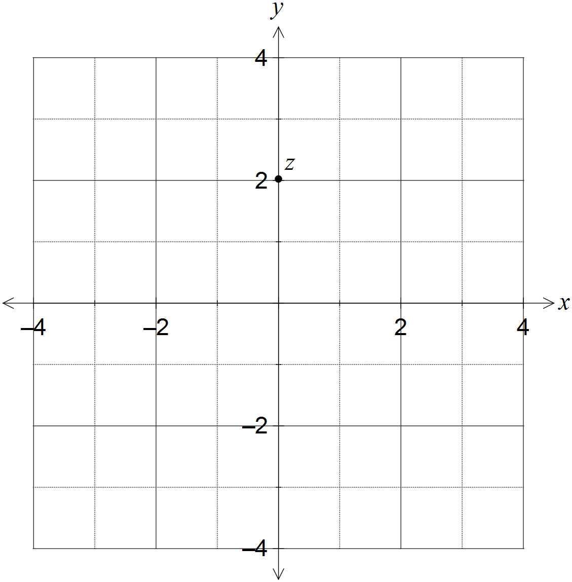

Question 10 (8 marks)

Two functions are given by  and .

(a) Determine  and state the domain and range of this composite function. (3 marks)

(b) Show that the composite function  is defined for . (3 marks)

(c) Sketch the graph of  on the axes below. (2 marks)

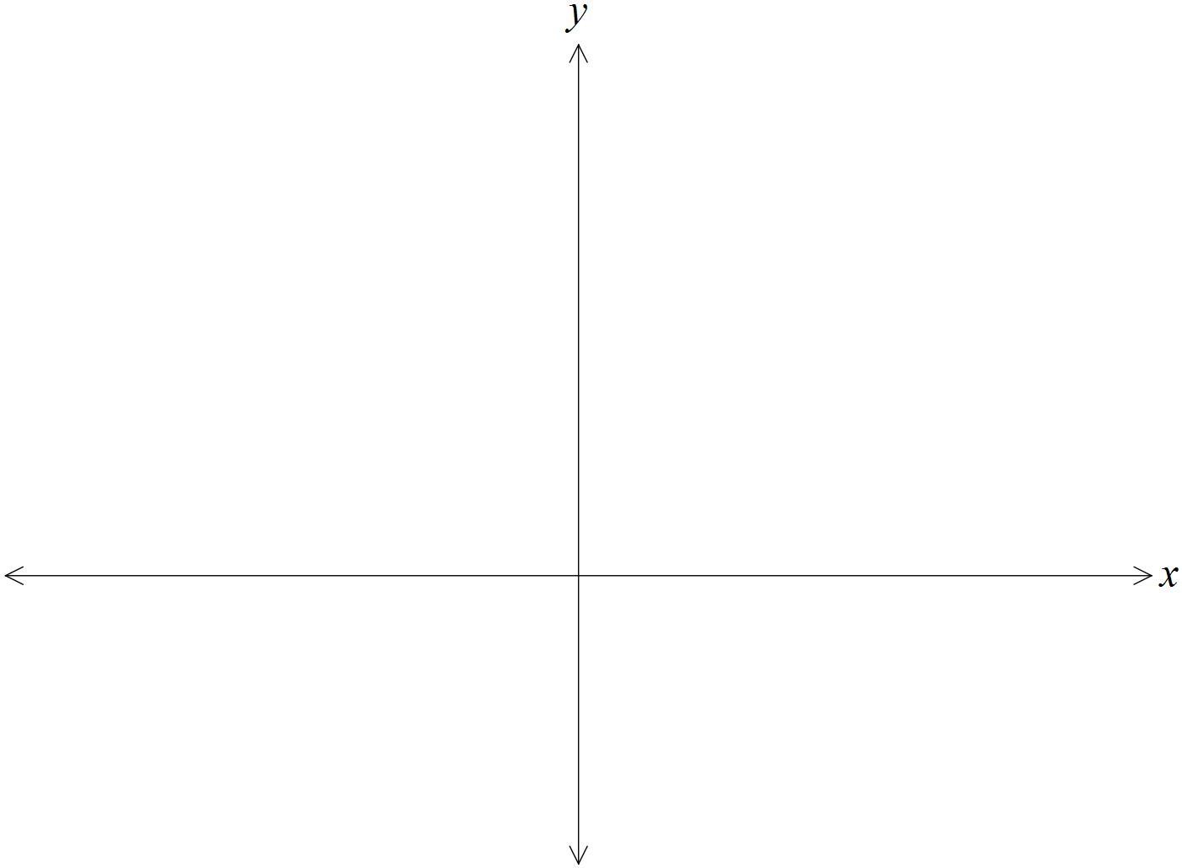

Question 11 (12 marks)

(a) The graph of  is shown below.

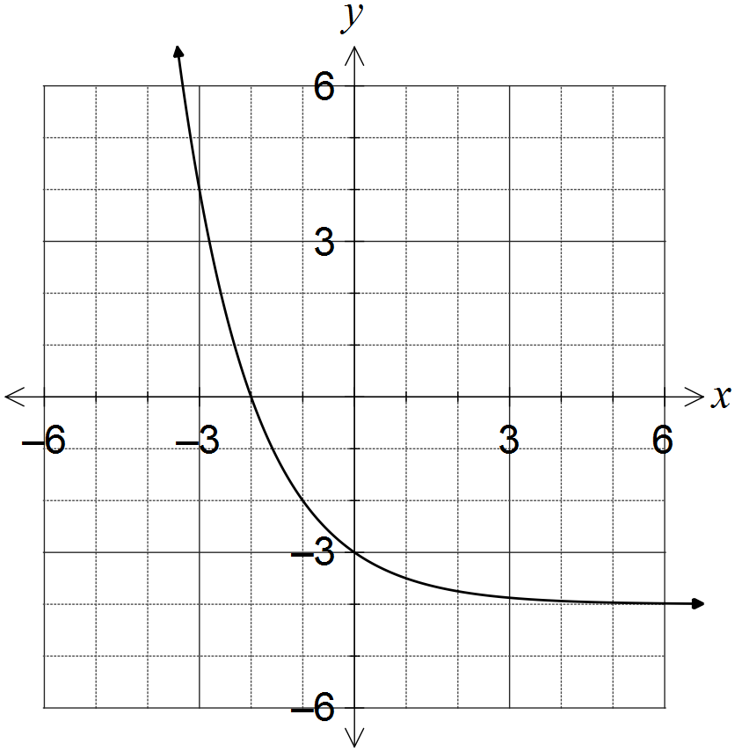

(i) What feature of the graph suggests that the inverse of f is a function? (1 mark)

(ii) On the same axes, sketch the graph of the inverse of f, . (3 marks)

(b) The graph of  is shown below.

On the same axes, sketch the graph of . (3 marks)

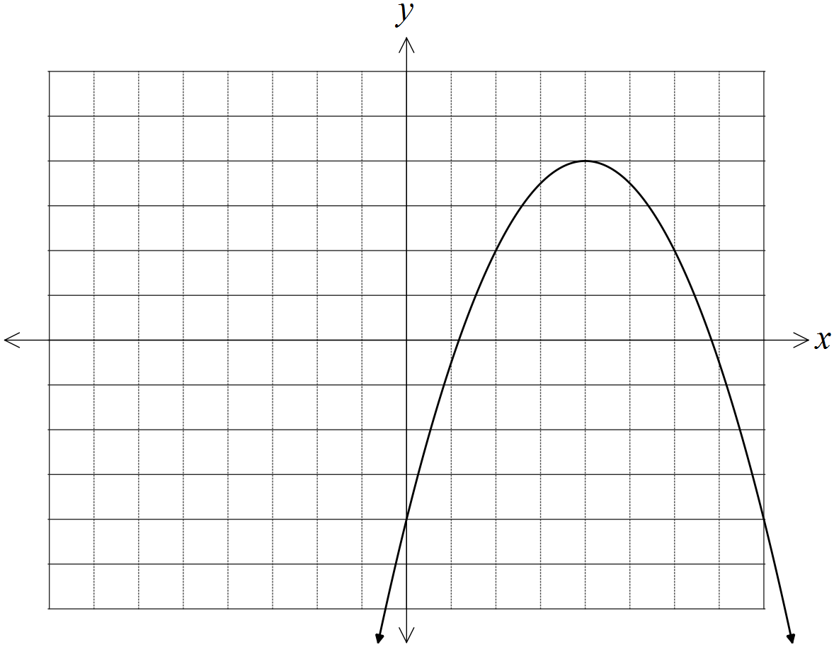

(c) The graph of  is shown below. As . On the same axes, sketch the graph of , clearly indicating all vertical and horizontal asymptotes.

(5 marks)

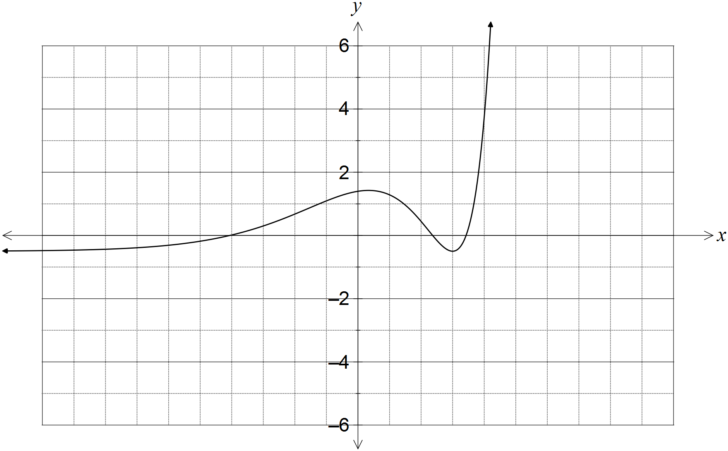

Question 12 (8 marks)

(a) Determine all roots of the equation , expressing them in exact polar form  where  and . (5 marks)

(b) Show all solutions of the equation on the Argand diagram below. (3 marks)

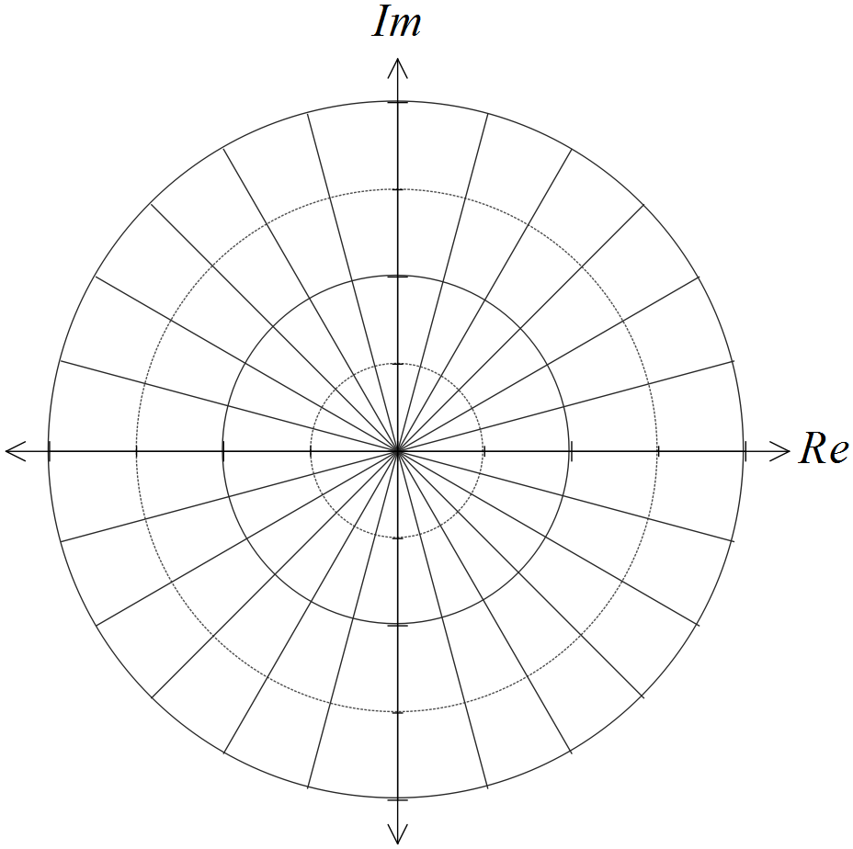

Question 13 (7 marks)

Two small bodies, A and B, simultaneously leave their initial positions of  and , and move with constant velocities of  and  respectively.

(a) Determine whether the paths of the bodies cross or if the bodies meet. (4 marks)

(b) At the same time, a third small body, C, leaves its initial position, passes through the origin and crosses the path of body A. If C moves with a steady velocity of , determine the value of the constant a. (3 marks)

Question 14 (9 marks)

The function f is defined by.

(a) Determine the natural domain and range of . (4 marks)

(b) Show that the function has no stationary points. (2 marks)

(c) Sketch the graph of  on the axes below. (3 marks)

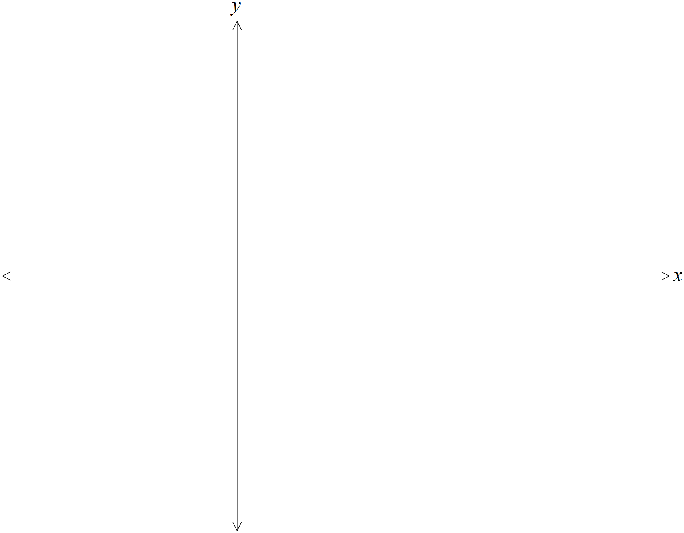

Question 15 (8 marks)

Given the two complex numbers  and , determine the following in terms of the non-zero constants r, s,  and :

(a) . (1 mark)

(b) . (2 marks)

(c) . (2 marks)

(d) . (3 marks)

Question 16 (7 marks)

Consider the three vectors ,  and .

(a) Prove that the three vectors do not lie in the same plane. (4 marks)

(b) Determine the value(s) of the constant a if the vector  lies in the same plane as vectors  and . (3 marks)

Question 17 (9 marks)

Let the complex number .

(a) Show that . (2 marks)

(b) Show that . (2 marks)

(c) Determine  in terms of  and .

(3 marks)

(d) Express  in terms of  and . (2 marks)

Question 18 (13 marks)

The velocity vector of a particle at time t seconds is , for . When , the particle has position vector .

(a) Calculate the exact speed of the particle when . (2 marks)

(b) Determine the acceleration vector of the particle and comment on its direction. (2 marks)

(c) Determine the position vector of the particle for . (2 marks)

(d) Derive the Cartesian equation of the path of the particle in the form . (2 marks)

(e) On the axes below, sketch the path taken by the particle for , clearly indicating the position of the particle at the start and end of this interval. (3 marks)

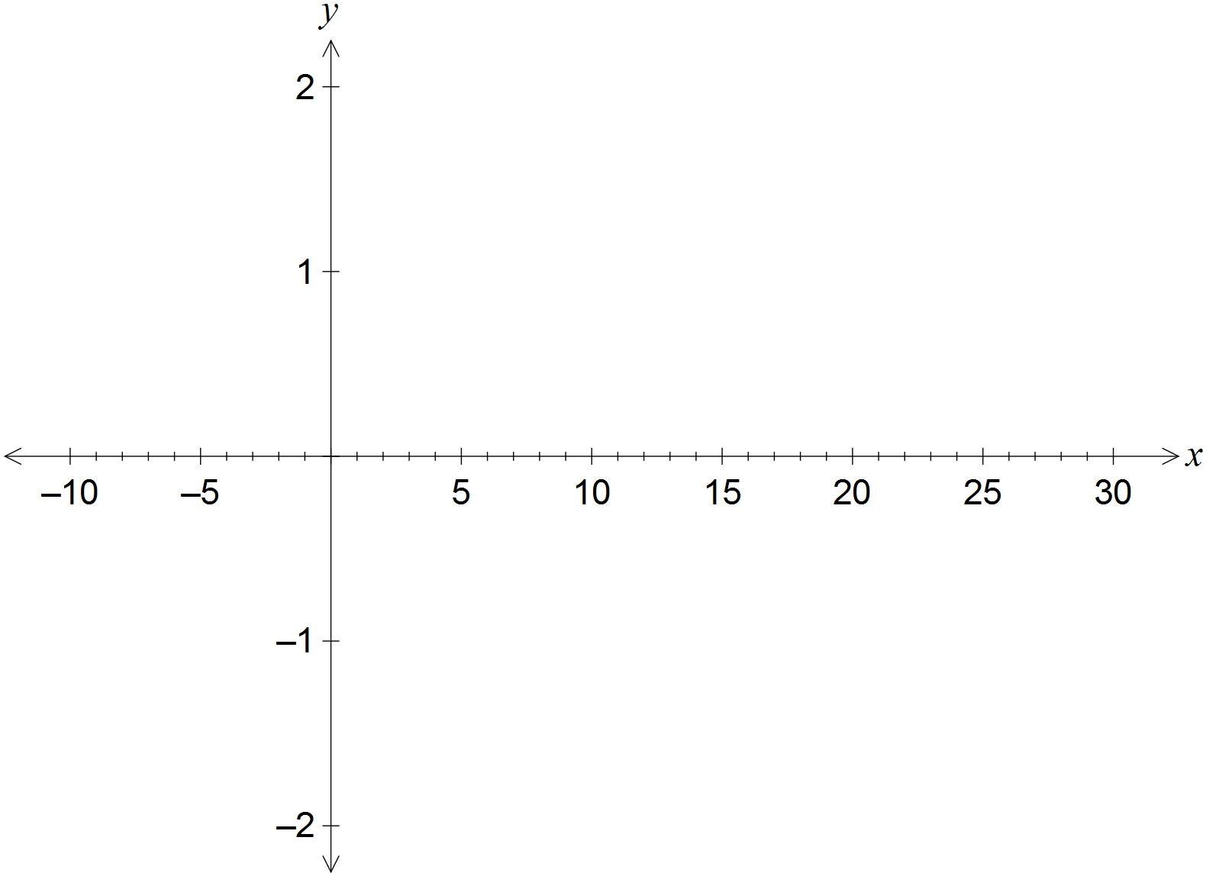

(f) Determine the length of the path travelled by the particle between  and .

(2 marks)

Question 19 (7 marks)

(a) Shade the region satisfying the complex inequality  on the Argand diagram below. (3 marks)

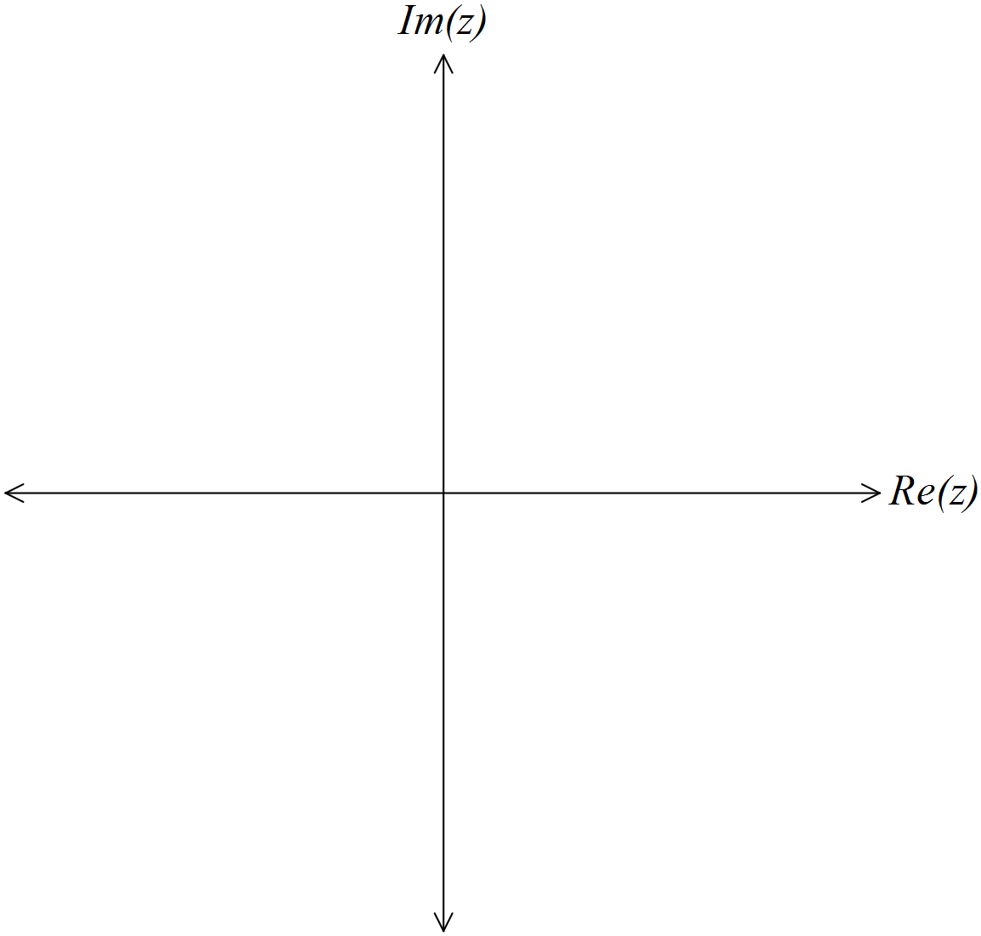

(b) Consider the two complex numbers given by  and . Sketch each of the following sets of points in the complex plane.

(i) . (2 marks)

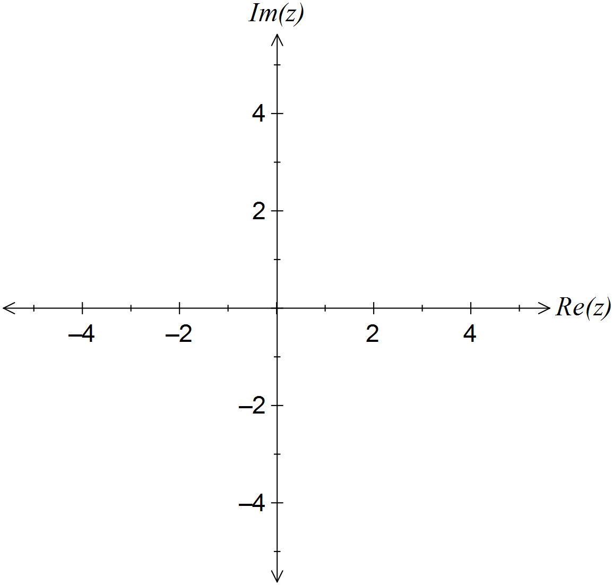

(ii) . (2 marks)



Additional working space

Question number: _________

Additional working space

Question number: _________

Additional working space

Question number: _________

Additional working space

Question number: _________

© 2016 WA Exam Papers. Rossmoyne Senior High School has a non-exclusive licence to copy and communicate this paper for non-commercial, educational use within the school. No other copying, communication or use is permitted without the express written permission of WA Exam Papers.